Làm 2 bài sau

Bài 1: Có css (external)

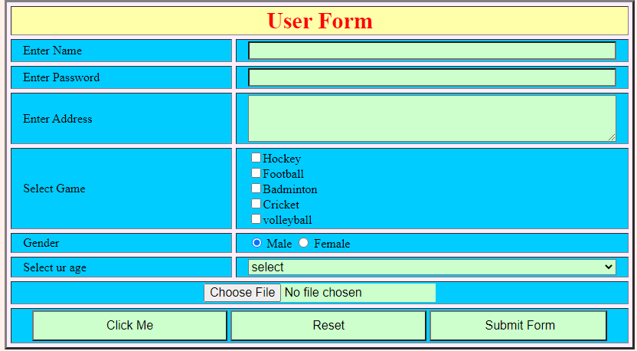

Bài 2: Có css (external)

